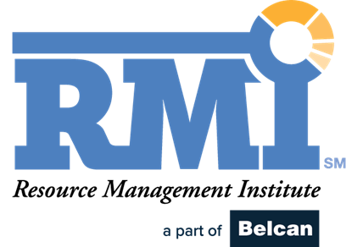

Resource Manager Career Growth & Development Worksheet
This worksheet is designed to help you reflect on your current skills, identify growth opportunities, and create a personalized career development plan. Use it regularly (at least bi-annually) to guide career development planning and conversations.

1. Core Skill Building Blocks
Skill Area | Self-Rating (1–5) |  | Current Strengths | Development Opportunity |  | Next Action Step
Supply/Skills
Know your supply role and skills
Learn about your resources
Collaborate with functional managers to ensure skills data is current
Facilitate change and ongoing improvement to role and skills data
Staffing
Build relationships with stakeholders
Get the right data for supply and demand
Be prepared to run a staffing meeting
Think outside the box to build matches
Consider resource wants and needs in addition to 'fit'
Project professionalism to overcome staffing challenges
Forecasting
Proactively analyze demand data
Be curious and look for trends
Be prepared at Interlocks with questions about demand
Be flexible and adapt to changes
Empathize and put yourself in others’ shoes
Challenge and push back on bad behavior
Sourcing and Development
Focus on understanding outlook of supply vs demand
Analyze data to find gaps in ability to meet future demand
Collaborate with HR/Leadership/Partners/Contractors
Technology
Know your systems of record for RM data
Understand how to fix data issues/inconsistencies
Encourage support/adoption of RM tools
Champion improvement efforts
Governance
Know and understand policy/process/roles/responsibilities
Facilitate and participate in meetings; complete action items
Drive compliance and participation
Identify process improvement opportunities

Rating Scale
1: Beginner, no or very limited knowledge/experience
2: Growing, some knowledge/experience
3: Capable, can accomplish with limited support
4: Skilled, can accomplish without support
5: Expert, deep experience, can train/mentor others

2. Career Development Reflection Questions
- Which skills are your strongest today?
- Which three skills would have the biggest impact if you improved them?
- What support or training do you need (mentorship, tools, courses, stretch assignments)?

3. Goal Setting
Short-Term (Next 3–6 Months):
Skill(s) to focus on: ___________________________
Development action: ___________________________
Success measure: ___________________________

Mid-Term (6–12 Months):
Skill(s) to focus on: ___________________________
Development action: ___________________________
Success measure: ___________________________

Long-Term (1–3 Years):
Skill(s) to focus on: ___________________________
Development action: ___________________________
Success measure: ___________________________

4. Career Pathing Questions
- What role(s) do I aspire to in the next 3–5 years?
- Which of the above skill building blocks are critical for success in that role?
- Who can mentor or support me in this journey?
- What projects or stretch assignments can I take on to grow?

5. Action Tracker
Date | Skill/Focus Area | Action Taken | Outcome | Next Step

